**DBMS LAB 4**

**PROGRAM 4: STUDENT FACULTY DATABASE**

Consider the following database for student enrollment for course:

STUDENT (snum#: int, sname: string, major: string, level: string, age:int)

CLASS (name: string, meets-at: time, room: string, fid: int)

ENROLLED (snum: int, cname: string)

FACULTY (fid#: int, fname: string,deptid: int)

**create table student(snum int,sname varchar(60),major varchar(60),level varchar(6),**

**age int,primary key(snum));**

**create table faculty(fid int,fname varchar(60),deptid int,primary key(fid));**

**create table class(cname varchar(60),meets_at timestamp,room varchar(60),fid int,**

**primary key(cname),foreign key(fid) references faculty(fid));**

**create table enrolled(snum int,cname varchar(60),primary key(snum,cname),foreign key(cname)**

**references class(cname),foreign key(snum) references student(snum));**

**insert into student values(1,'john','cs','sr',19),**

**(2,'smith','cs','jr',20),(3,'jacob','cv','sr',20),(4,'tom','cs','jr',20),**

**(5,'rahul','cs','jr',20),(6,'rita','cs','sr',21);**

**insert into faculty values(11,'harish',1000),(12,'manav',1000),**

**(13,'mira',1001),(14,'shiva',1002),(15,'nupur',1000);**

**insert into class values('class1','12/11/15 10:15:16','R1',14),**

**('class10','12/11/15 10:15:16','R128',14),**

**('class2','12/11/15 10:15:20','R2',12),**

**('class3','12/11/15 10:15:25','R3',12),**

**('class4','12/11/15 10:15:20','R4',14),**

**('class5','12/11/15 20:15:20','R3',15),**

**('class6','12/11/15 13:20:20','R2',14),**

**('class7','12/11/15 10:10:10','R3',14);**

**insert into enrolled values(1,'class1'),(2,'class1'),(3,'class3'),**

**(4,'class3'),(5,'class4'),(1,'class5'),(2,'class5'),(3,'class5'),**

**(4,'class5'),(5,'class5');**

**select*from student;**

**select*from class;**

**select * from enrolled;**

**select*from faculty;**

Enrolled has one record per student-class pair such that the student is enrolled in the class. Level is a 2 character code with 4 different values.

1. Find the names of all juniors (level=JR) who are enrolled in a class taught by

**select distinct s.sname from student s,class c,enrolled e,faculty f where s.snum=e.snum and e.cname=c.cname and c.fid=f.fid and f.fname='shiva' and s.level='jr';**

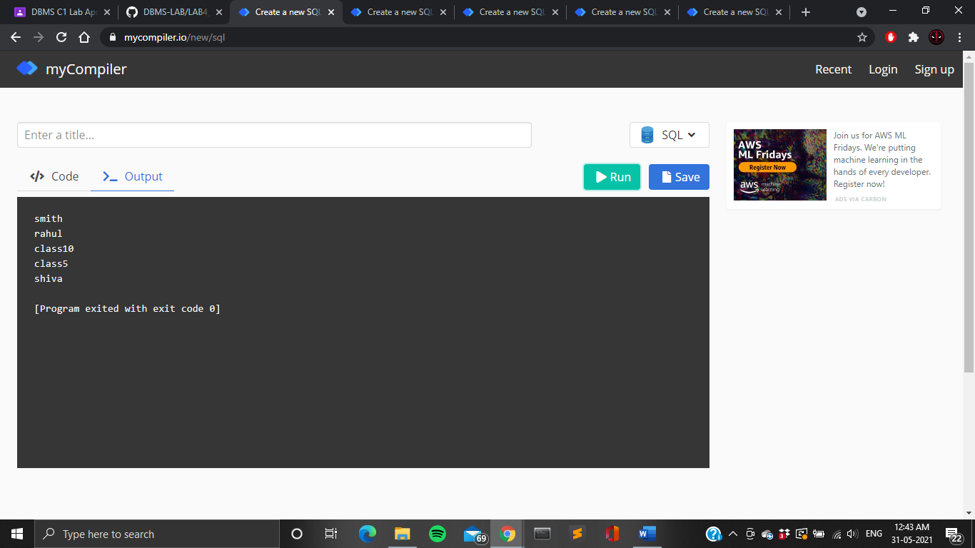

1. Find the names of all classes that either meet in room R128 or have 5 or more students enrolled.

**select c.cname from class c where c.room='R128' or c.cname in(select e.cname from enrolled e,class c where c.cname=e.cname group by e.cname having count(*)>=5);**



1. Find the names of all students who are enrolled in 2 classes that meet at the same time.

**select distinct s.sname from student s where s.snum in (select e1.snum from enrolled e1,enrolled e2,class c1,class c2 where e1.snum=e2.snum and e1.cname<>e2.cname and e1.cname=c1.cname and e2.cname=c2.cname and c1.meets_at=c2.meets_at);**

1. Find the names of faculty members who teach in every room in which some class is taught

**select f.fname from faculty f where f.fid in(select fid from class group by fid having count(*)=(select count(distinct room)from class));**



1. Find the names of faculty members for whom the combined enrollment of the courses that they teach is less than 5

**select distinct f.fname from faculty f where 5>(select count(e.snum) from class c,enrolled e where c.cname=e.cname and c.fid=f.fid);**

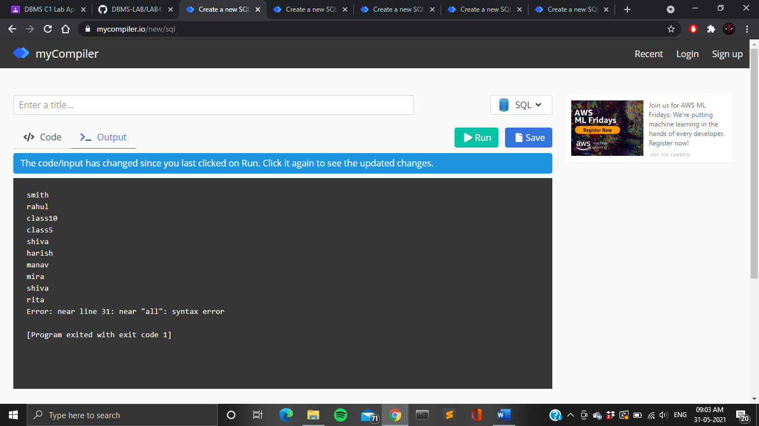

1. Find the names of students who are not enrolled in any class.

**select distinct s.sname from student s where s.snum not in (select e.snum from enrolled e);**



1. For each age value that appears in students, find the level value that appears most often.

**select s.age,s.level from student s group by s.age,s.level having s.level in( select s1.level from student s1 where s1.age=s.age group by s1.level,s1.age having count(*)>=all(select count(*) from student s2 where s1.age=s2.age group by s2.level,s2.age));**

